AASIGNMENT:
1. Write a program to implement Constructor concept with multilevel inheritance.
class s1
{
s1()
{
System.out.println("Sample1");
}
}
class s2 extends s1
{
s2()
{
System.out.println("Sample2");
}
}
class s3 extends s2
{
s3()
{
System.out.println("Sample3");
}
}
class s4 extends s3
{
s4()
{
System.out.println("Sample4");
}
}
class arun
{
public static void main(String args[])
{

s4 ob=new s4();
}
}


3. Write a program to implement static concept with multilevel inheritance creating object in the sequence c3,c2,c1,p.
class s1
{
static
{
System.out.println("Sample1");
}
}
class s2 extends s1
{
static
{
System.out.println("Sample2");
}
}
class s3 extends s2
{
static
{
System.out.println("Sample3");
}
}
class s4 extends s3
{
static
{
System.out.println("Sample4");
}
}
class arun
{
public static void main(String args[])
{

System.out.println("4 level");
s4 ob4=new s4();
System.out.println("3 level");
s3 ob3=new s3();
System.out.println("2 level");
s2 ob2=new s2();
System.out.println("1 level");
s1 ob1=new s1();

}
}
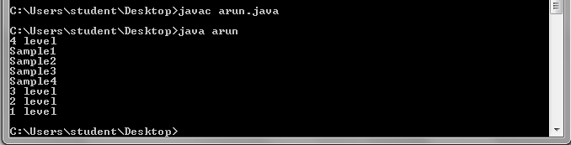

2. Write a program to implement static concept with multilevel inheritance creating object in the sequence p,c1,c2,c3,etc.
class s1
{
static
{
System.out.println("Sample1");
}
}
class s2 extends s1
{
static
{
System.out.println("Sample2");
}
}
class s3 extends s2
{
static
{
System.out.println("Sample3");
}
}
class s4 extends s3
{
static
{
System.out.println("Sample4");
}
}
class arun
{
public static void main(String args[])
{

System.out.println("1 level");
s1 ob1=new s1();
System.out.println("2 level");
s2 ob2=new s2();
System.out.println("3 level");
s3 ob3=new s3();
System.out.println("4 level");
s4 ob4=new s4();

}
}
